**Name: Muhammad Awais**

**Student ID : 22027179**

**The COVID-19 Pandemic Analysis**

**Github link :** [**https://github.com/anayatawais/visualization**](https://github.com/anayatawais/visualization)

**Table of Contents**

1. Introduction 3

2. Data Visualization 3

2.1. Bar Plot 3

2.2. Vertical Bar plot 4

2.3. Horizontal Bar Plot 4

2.4. Stacked Bar Chart 5

Summary 5

**List of Figures**

Figure 1: Top 10 Death Cases Countries 3

Figure 2: Top 10 Active Cases Countries 4

Figure 3: Most Affected States in the USA 5

Figure 4: Most Affected States in India 5

# **Introduction**

In this work, the developed code is a Python script that analyzes and visualizes data related to the COVID-19 pandemic using the Pandas, Matplotlib, and Plotly libraries. The code begins by importing the required libraries: pandas, matplotlib, plotly, numpy, and datetime. It also imports several classes and functions from the Plotly library.

Next, the code retrieves data from a web service using the requests library and converts the data into a pandas DataFrame. The data is then transformed and cleaned to remove any missing values and convert the Last Update column from Unix timestamps to datetime objects.

# **Data Visualization**

## **Bar Plot**

The second chart is a horizontal bar plot that shows the top 10 countries with the most deaths due to COVID-19. The bars are colour-coded based on the number of deaths, with a blue-to-red colour scale.

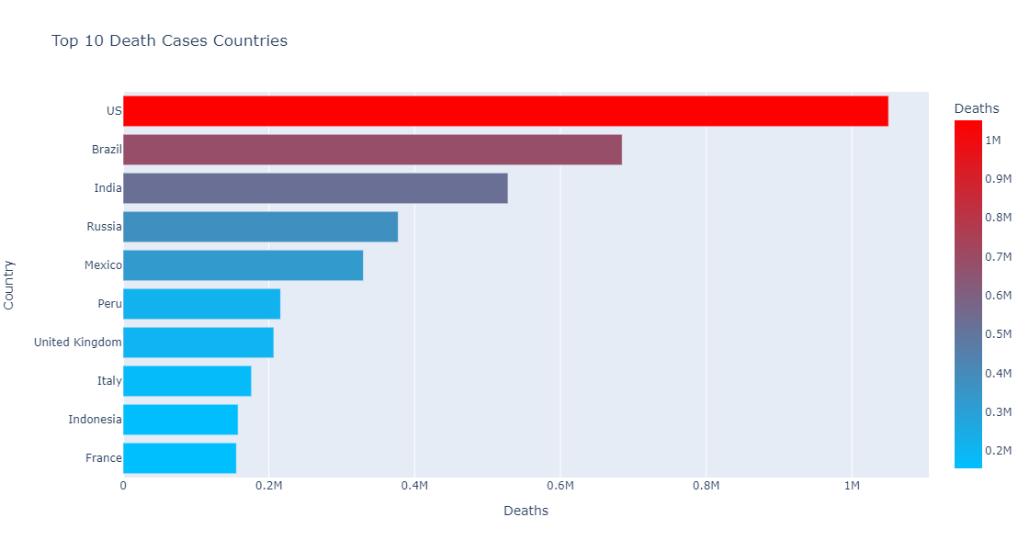

Figure 1: Top 10 Death Cases Countries

## **Vertical Bar plot**

The third chart is a vertical bar plot that shows the top 10 countries with the most recovered cases of COVID-19. The bars are colour-coded based on the number of recovered cases, with a green-to-yellow colour scale.

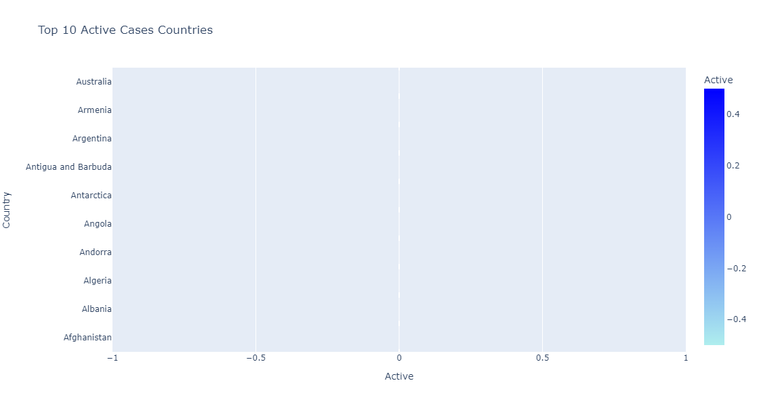

Figure 2: Top 10 Active Cases Countries

## **Horizontal Bar Plot**

The fourth chart is a horizontal bar plot that shows the top 10 countries with the most active cases of COVID-19. The bars are colour-coded based on the number of active cases, with a blue-to-green colour scale.

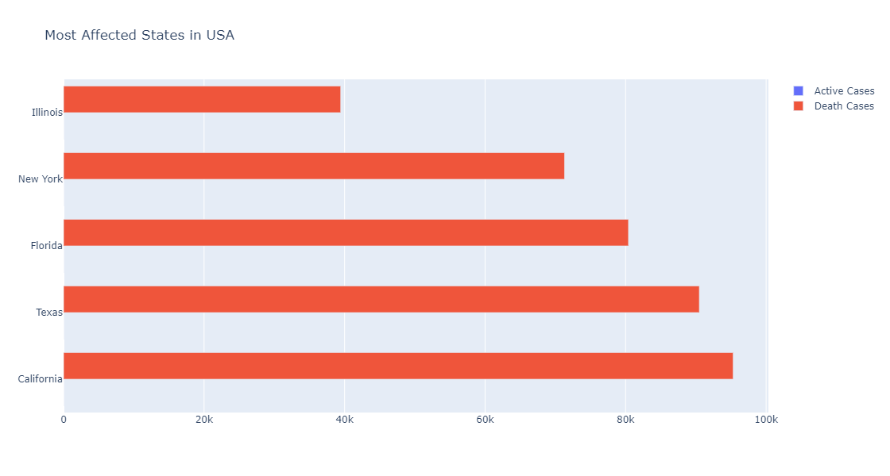

Figure 3: Most Affected States in the USA

## **Stacked Bar Chart**

The code then proceeds to visualize the most affected states in four specific countries: the United States, Brazil, India, and Russia. For each country, the code identifies the top 5 states with the most confirmed cases of COVID-19 and creates a stacked bar chart that shows the number of active, recovered, and death cases for each state.

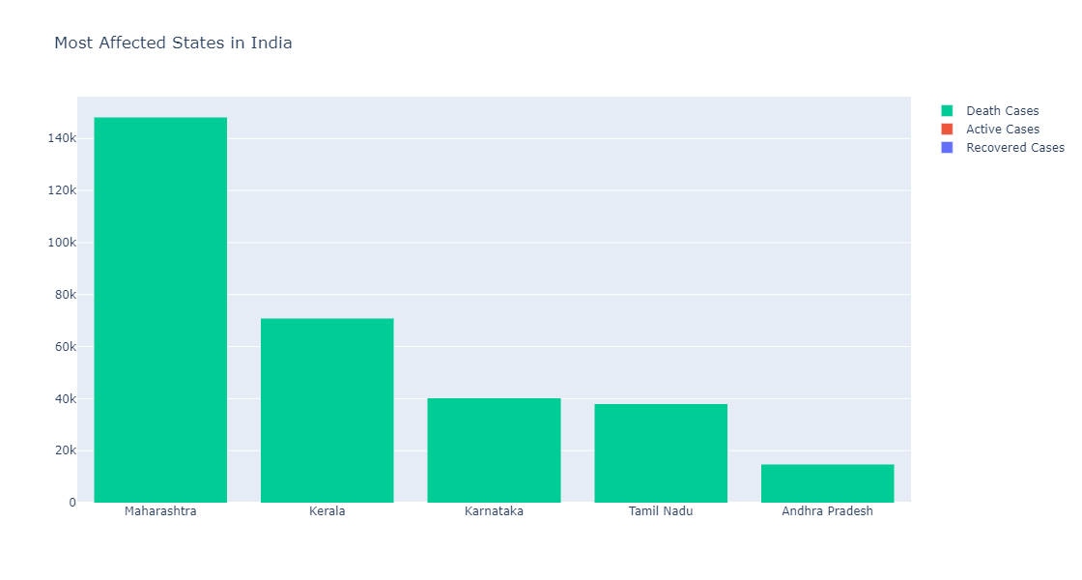

Figure 4: Most Affected States in India

Finally, each chart is displayed using the Plotlyshow () function.

# **Summary**

In conclusion, the provided code demonstrates how to use Pandas, Matplotlib, and Plotly libraries to retrieve, transform, and visualize COVID-19 data. The code produces informative and visually appealing charts that provide insights into the pandemic's impact on various countries and regions.